Destelheide vzw Algemene Dienst voor Jeugdtoerisme Destelheidestraat 66, 1653 Dworp
Tel: +32 2 380 39 15 /Fax: +32 2 380 52 51
info@destelheide.be /www.destelheide.be

De Put hall technical sheet

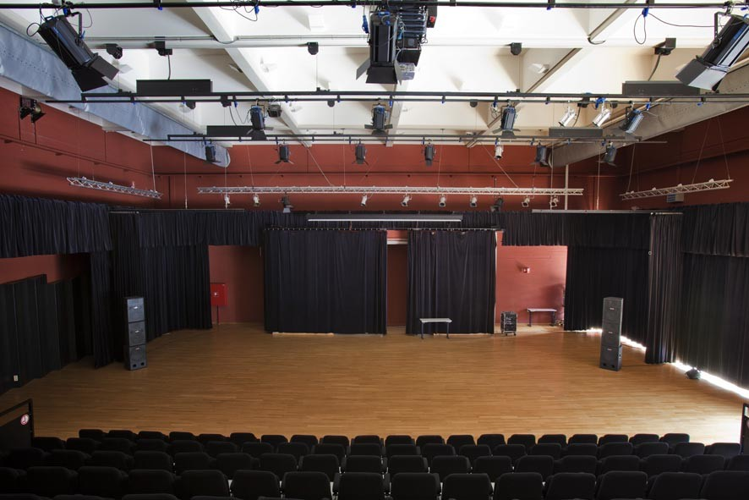

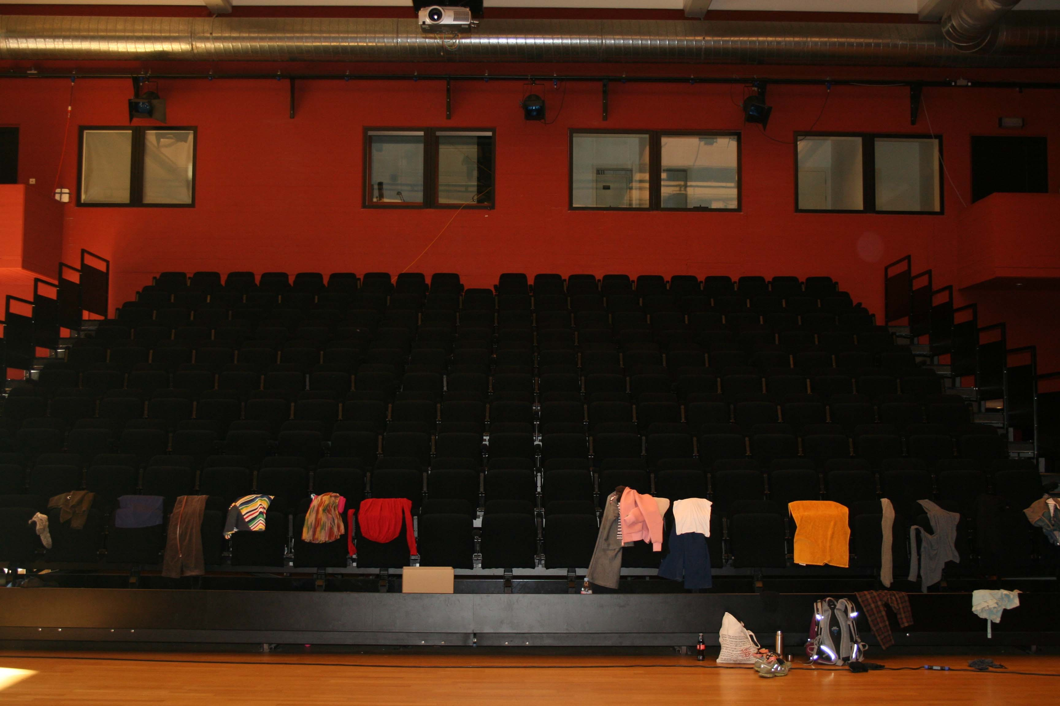

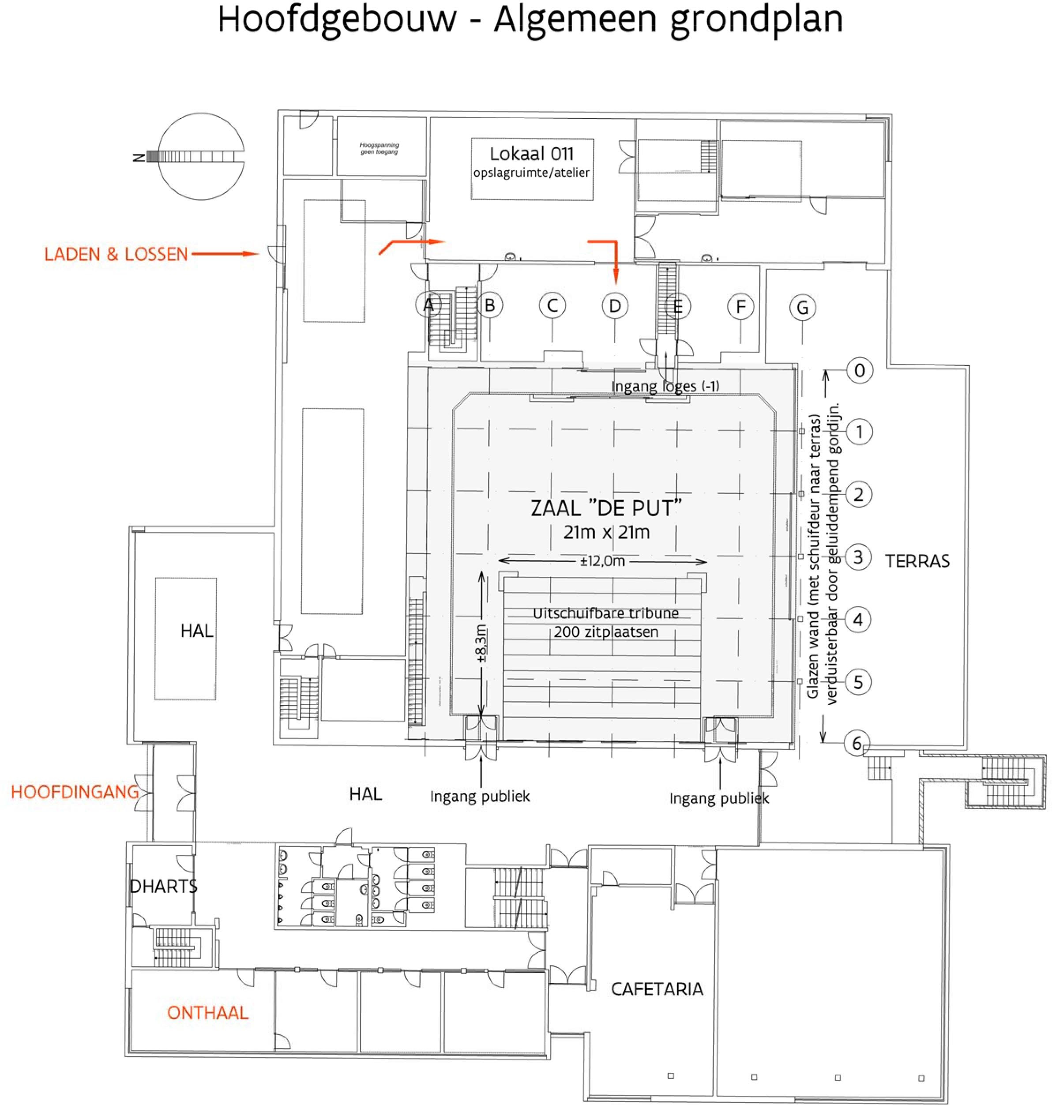

Hoofdgebouw – Algemeen grondplan | Main building – General floor plan
LADEN & LOSSEN | LOADING & UNLOADING
HOOFDINGANG | MAIN ENTRANCE
ONTHAAL | RECEPTION AREA
HAL | HALLWAY
Hoogspanning  geen toegang | High voltage  no access
Lokaal 011  opslagruimte / atelier | Room 011  storage space/workshop
Ingang loges (-1) | Entrance boxes (-1)
ZAAL “DE PUT” | “DE PUT” HALL
Uitschuifbare tribune  200 zitplaatsen | Extendable stand  200 seats
Ingang publiek | Entrance for the public
CAFETARIA | CAFETERIA
Glazen wand (met schuifdeur naar terras)  verduisterbaar door geluiddempend gordijn. | Glass wall (with sliding door to the terrace)  can be darkened by sound-absorbing curtain.
TERRAS | TERRACE

General

- Entire room: 21 m x 21 m
- Height under the spot beams: 7 m
- Retractable grandstand with 200 seats can only be extended in full
- Capacity can be expanded to 350 seats with chairs
- Room can be darkened completely by electric window curtain; can only be operated from the balcony after explanation by the technician
- 1 curtain stage right and 1 curtain stage left; can be opened or closed by sliding
- Parquet floor
- 10-metre-wide x 8-metre-deep dance floor available
- 8 Hanging points and 4 water barrels available (see technical sheet ‘hanging points’)
- 32 podium elements 2 m² each (64 m²), adjustable height (20 cm to 80 cm)
- 2 pulpits
- Buffet piano (prices can be requested at the reception desk or from the technical team)
- 2 dressing rooms accessible from the De Put Hall, via a staircase
each one contains: 3 washbasins, 4 make-up mirrors with lamps, 2 dressing mirrors, 1 table, 10 chairs, 5 stools
separately in the corridor: toilet, showers (2 for women, 2 for men)
- Catering: 15 walking dinner tables and 3 buffet tables (with canopy) available

Request (cross out what does not apply):

Grandstand retracted/extended
Extra chairs (number: …)/no extra chairs
Dance floor/no dance floor
Hanging points/no hanging points Water barrels/no water barrels
Podium elements (number: …)/no podium elements Pulpits/no pulpits
Buffet piano/no buffet piano
Dressing rooms (number: …)/no dressing rooms
Walking dinner tables (number: …)/no walking dinner tables Buffet tables (number: …)/no buffet tables

Audio

- 6 speakers Active 2-Way Line-Array Module 2x8/1x2,5, 900W/RMS,
- 4 bass cabinets: Active 1x18" Subwoofer Bass-Reflex 1600W/RMS, RD-Net
- 7 speaker monitors JBL Eon610 active speakers
- 3 vocal microphones: SM58 (Shure)
- 4 wireless microphones (Sennheiser E835)
- 20 wired microphones: type Behringer and MICPRO1
- 8 stands for microphones (+ 20 table stands)
- Information about XLR cables and fittings can be obtained from the head technician.
- Small installation with mixing desk (brand: Allen&Heath ZED14) with max. 6 microphones (2 wireless and 4 with XLR connection or 6 with XLR connection),
2 CD players. Can be done without a technician.
- Mixing desk (brand: Behringer type: X32) controllable from the control room or from the hall. Destelheide technician always needed.

Audio request:

…

Projector

- Projector type: Panasonic PT-DW830E
- Video projection on white electric extendible background screen (see below for size)
- Fixed projector with VGA and HDMI connection and wireless connection via Clickshare (will be explained on site)
- Mac adapter available for VGA and HDMI connection
- (Also available: overhead projector and small screen)

Projector specifications: Panasonic PT-DW830E
Number of pixels: 1,024,000 pixels (1280 x 800 dots)
Lens: electric zoom: 1.8 - 2.5:1 and electric focus: F = 1.7 – 1.9. f = 25.6mm – 35.7 mm Luminous lamp: 420 W UHM lamp x2
Light output: 8500 lumen (ANSI) Screen aspect ratio: 16:10

Request (cross out what does not apply):

Use of projector and background screen/no use of projector and background screen
Mac adapter/no Mac adapter
Overhead projector and small screen/no overhead projector and small screen

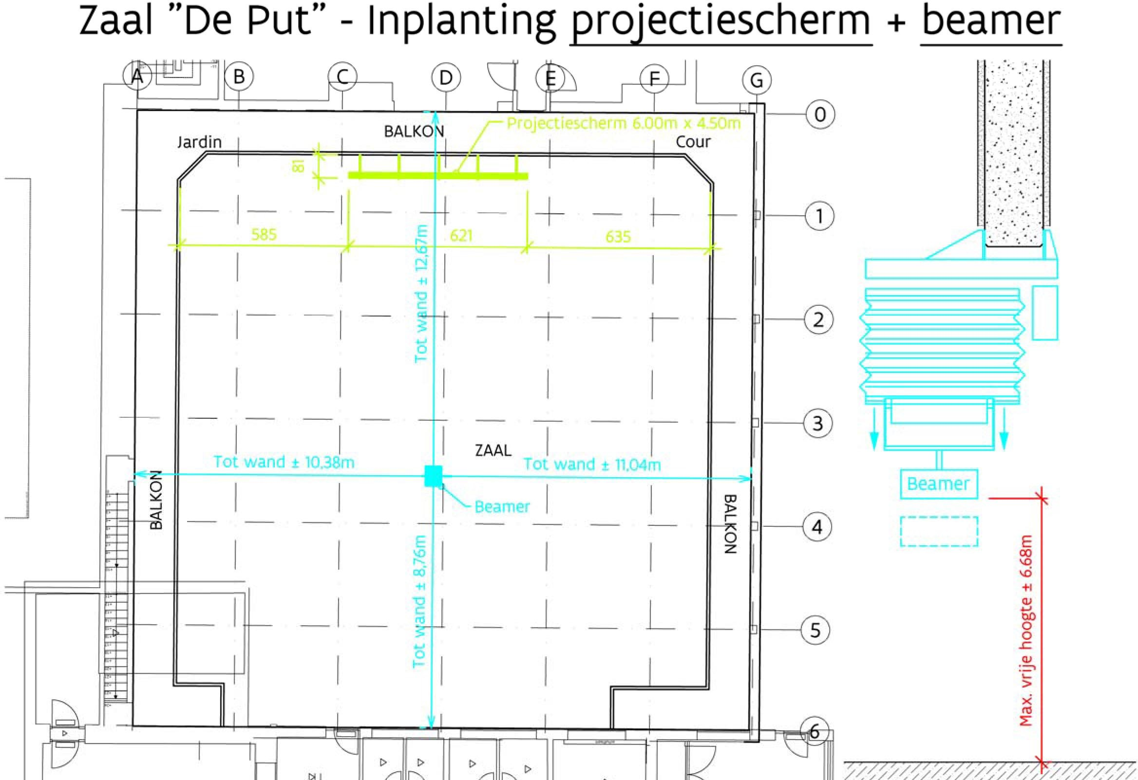

Zaal “De Put” – Inplanting projectiescherm + beamer | “De Put” Hall – Projection screen + projector installation
Jardin | Stage left
BALKON | BALCONY
Cour | Stage right
Projectiescherm 6.00m x 4.50m | Projection screen 6 m x 4.50 m
Tot wand | To wall
Beamer | Projector
Max. vrije hoogte | Max. free height
Vloer | Floor

Lighting

- 6x 2 KW PC spotlights
- 12x 1 KW PC spotlights
- 2x profile floodlights
- 20x 300 W par lamps
- 4 stands for individual spotlights available (which must be connected to the spot beams, no light connections on the sides or floor available)
- Complete colour book of colour filters
  - White (without filter)
  - Yellow (l100s)
  - Bright orange (l105r)
  - Pink (l113r)
  - Blue/green (l115r)
  - Dark blue (l118r)
  - Green (l121)
  - Dark green (l124)
  - Turquoise (l126r)
  - Dark blue (l141s)
  - Orange (l152r)
  - Red (164s)
  - Purple (l170s)
  - Blue (l174s)
- Mixing desk in the room: Lite-Puter CX-12, with 96 channels DMX dimming console, not programmable, operated manually.
- Mixing desk in the control room: ADB Cantor, with 96 channels, programmable, Destelheide technician always present. Can also be operated by a group technician upon presentation of a lighting technician's certificate.
- LED spots (100W/150W/160W/stage painters/stage beamers/cyclo bars/Moving heads/…) + Chamsys MagicQ MQ80

The backlight bar in the rear is a fixed light bar and can only be reached using an elevated work platform.
Light bar 4 can only be reached via the grandstand with a ladder, not with an aerial platform.
Side lighting via the balcony.

Lighting request: please make notes on the drawing on page 9

…

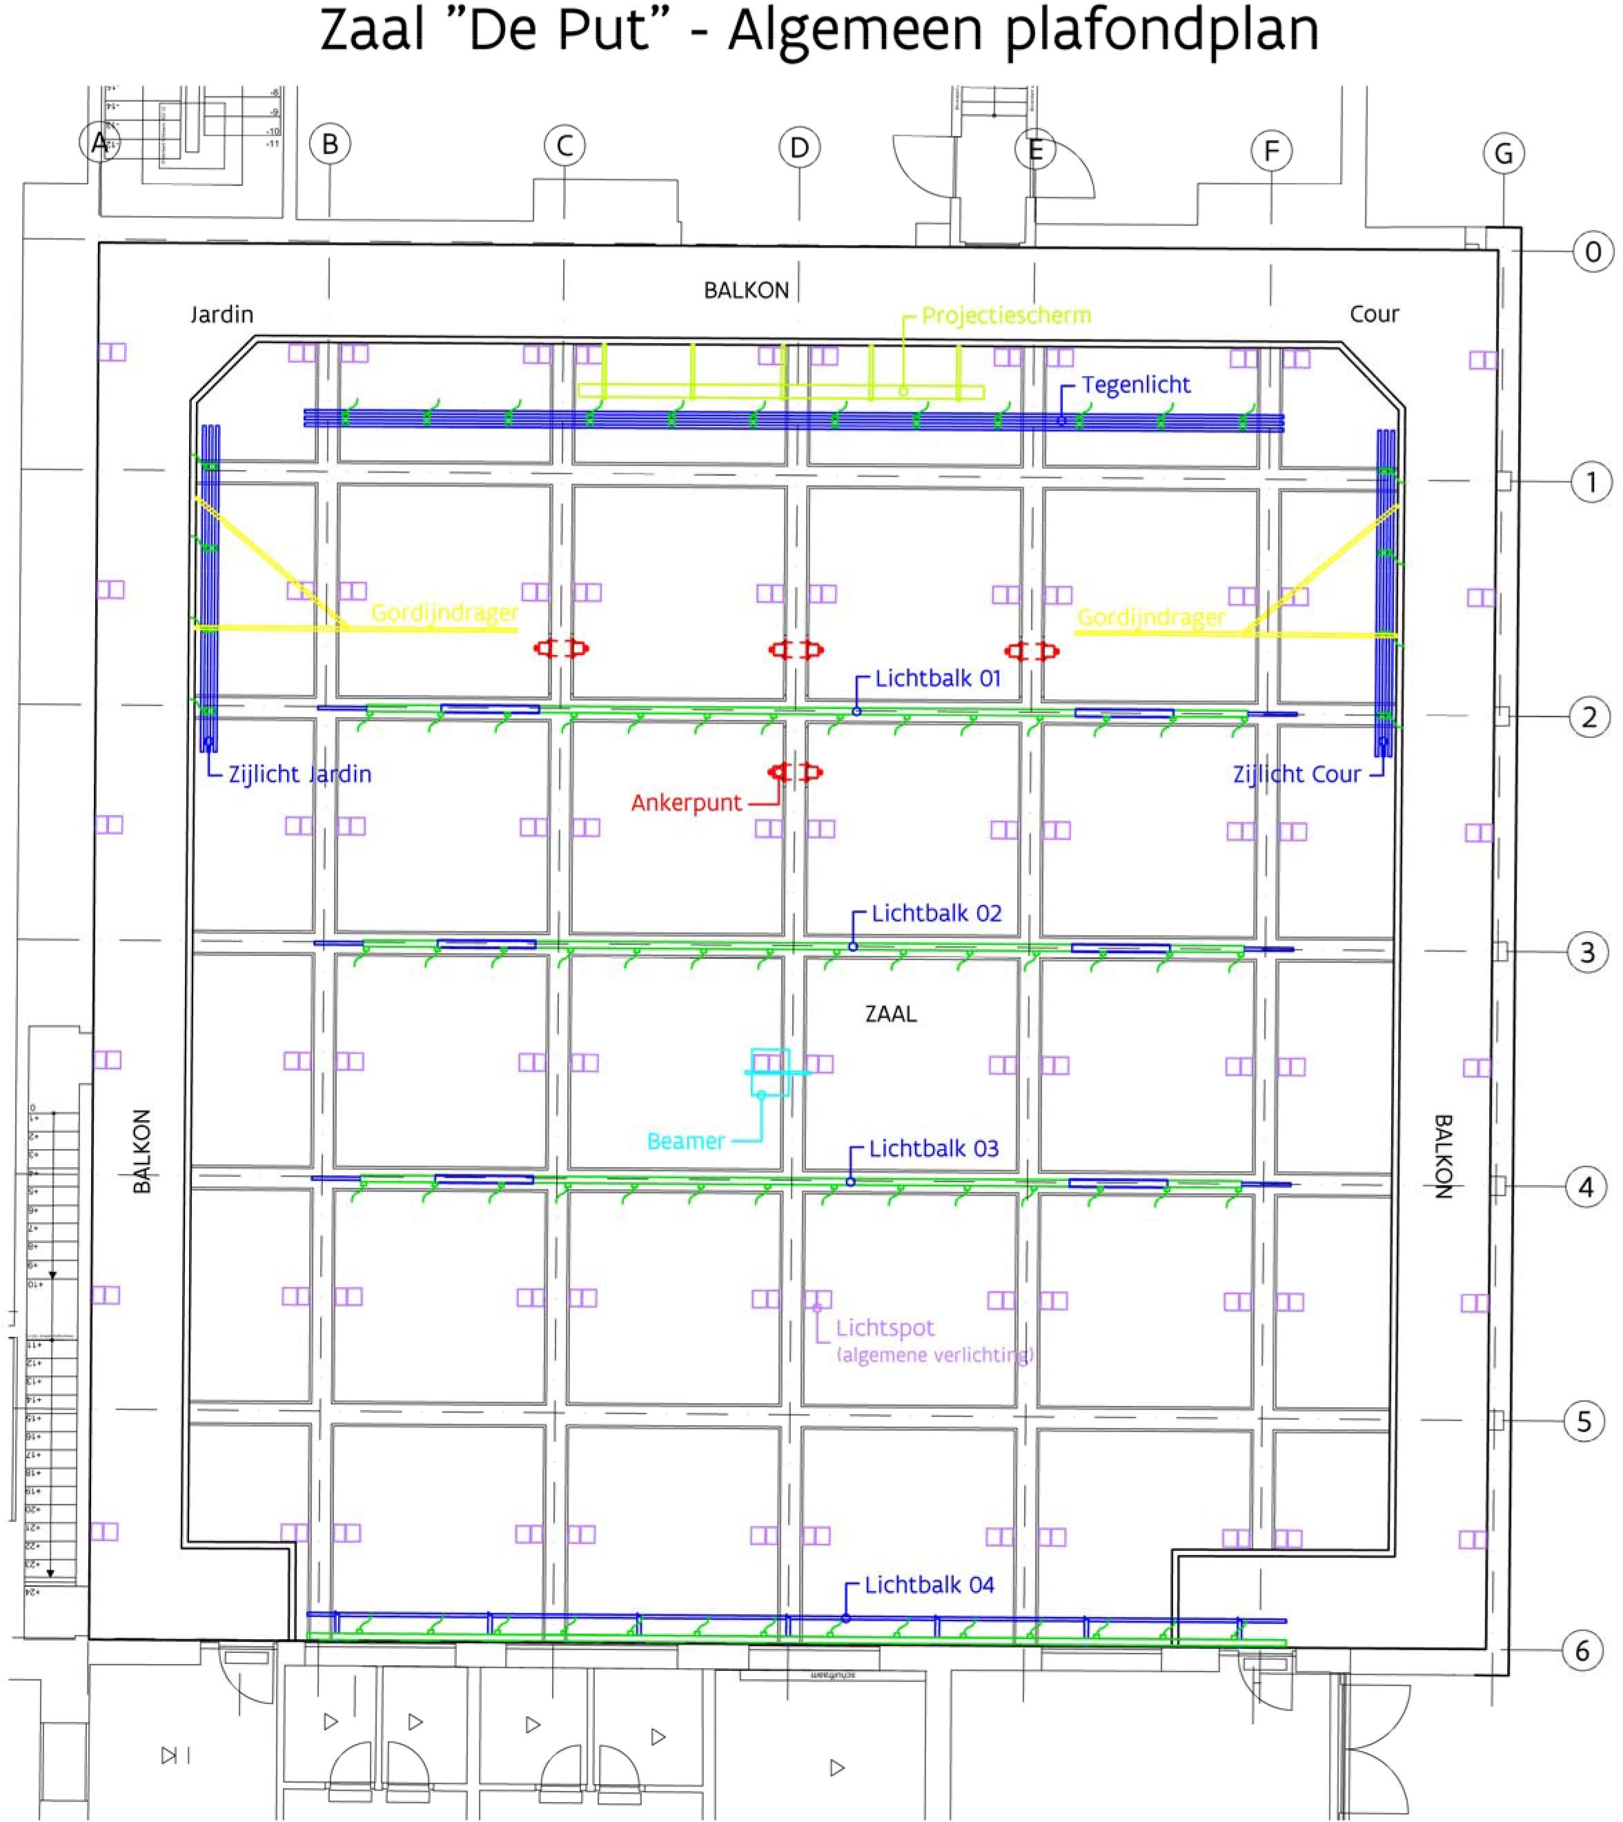

Zaal “De Put” – Algemeen plafondplan | “De Put” Hall – General ceiling plan
Jardin | Stage left
BALKON | BALCONY
Cour | Stage right
Projectiescherm | Projection screen
Tegenlicht | Backlight
Lichtbalk | Light bar
Zijlicht jardin | Sidelight stage left
Zijlicht cour | Sidelight stage right
Ankerpunt | Anchor point
Beamer | Projector
Lichtspot (algemene verlichting) | Light spot (general lighting)

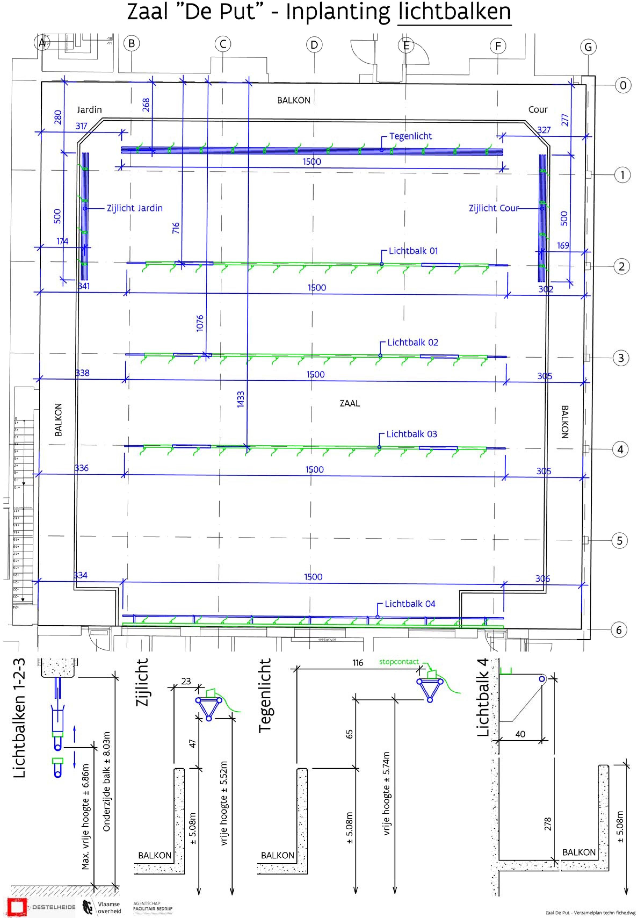

Zaal “De Put” – Inplanting lichtbalken | “De Put” Hall – Light bar installation
Jardin | Stage left
BALKON | BALCONY
Cour | Stage right
Tegenlicht | Backlight
Zijlicht jardin | Sidelight stage left
Zijlicht cour | Sidelight stage right
Lichtbalk | Light bar
Lichtbalken 1-2-3 | Light bars 1-2-3
Max. vrije hoogte | Max. free height
Onderzijde balk | Bottom of bar
Zijlicht | Sidelight
Tegenlicht | Backlight

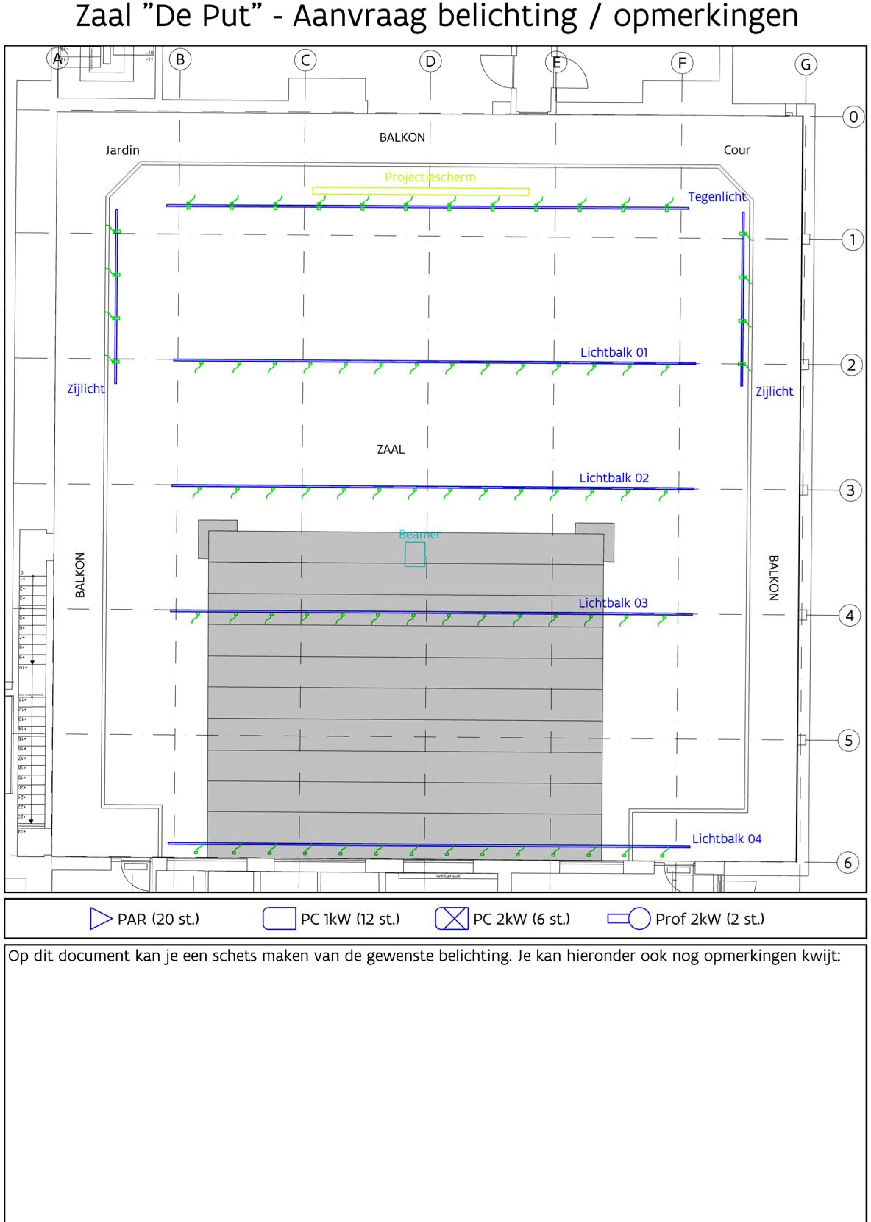

Zaal “De Put” – Aanvraag belichting / opmerkingen | “De Put” Hall – Request for lighting/ Comments
Jardin | Stage left
BALKON | BALCONY
Cour | Stage right
Projectiescherm | Projection screen
Tegenlicht | Backlight
Lichtbalk | Light bar
Zijlicht | Sidelight
ZAAL | HALL
Beamer | Projector
Op dit document kan je een schets maken van de gewenste belichting. Je kan hieronder ook nog opmerkingen kwijt: | On this document, you can draw a sketch of the desired lighting. You can also leave comments below:

Rules

- Loading and unloading is done via a sliding door where the unloading vehicle can be parked during loading and unloading only. Afterwards, it can be parked in the car park.
- Destelheide technicians are available during office hours, until 4 pm.
- Lighting, sound checks etc. must be requested in advance, both in terms of date and number of working hours.
- Technical assistance outside office hours will be charged.
- Ladders, aerial work platforms and light bars can be operated by your own qualified technician, provided that he/she takes responsibility in the event of damage and/or accident.
- Light bars are only suitable for hanging spotlights. No other weights or decor items can be hung from the bars. They cannot be used as a hoist.
- The balcony is only accessible to technicians.
- All materials you bring must comply with the applicable laws, Arab, Arei and Vlarem II.
- Technical materials can only be taken from backstage by a Destelheide technician.
- The use of smoke, fire, pyro-effects, water etc. is strictly prohibited.
- Smoking, eating and drinking are prohibited in the hall and on the stage.
- Damage to the parquet floor (for example, caused by decorative pieces) will be charged.
- If the group’s technician moves the spots, they must be returned to their original position afterwards (at the spot bars + plugged in).
- The room should be left swept and tidy after use.

Please send the completed technical sheet to reception at least two weeks in advance: info@destelheide.be

Technical assistance requested: yes/no (cross out what doesn’t apply)
If yes, on …………….. from ……………. until …………………

Set-up planned for …………….. from ……………. until …………………
Take-down planned for …………….. from ……………. until …………………

